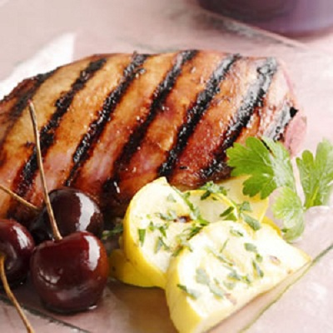

**Grilled Marinated Chicken**

2/3 cup olive oil

* 2/3 cup  soy sauce
* 1/4 cup lemon juice
* 2 tablespoons spicy brown mustard
* 2 teaspoons ground black pepper
* 2 teaspoons garlic powder
* 4 skinless, boneless chicken breast halves

**Directions**

1. In a large bowl, mix the olive oil, soy sauce, lemon juice, mustard, pepper, and garlic powder. Place chicken in the bowl, and coat with the marinade. Cover, and allow chicken to marinate a maximum of 4-5 hours in the refrigerator.
2. Preheat the grill for high heat.
3. Oil grill grate. Discard marinade, and place chicken on grate. Cook 6 to 8 minutes on each side, until juices run clear.

This is a simple recipe to use to make at home :)

Have this with Kachumbari or Chips or Mashed Potatoes